University of Central Missouri

Department of Computer Science & Cybersecurity

CS5760 Natural Language Processing

Spring 2026

Homework 1.

Student name: ARAGONDA GAYATHRI

Submission Requirements:
- Once finished your assignment push your source code to your repo (GitHub) and explain the work through the ReadMe file properly. Make sure you add your student info in the ReadMe file.
- Submit your GitHub link on the Bright Space.
- Comment your code appropriately IMPORTANT.
- Any submission after provided deadline is considered as a late submission.

Q1. Regex
Task: Write a regex to find
- U.S. ZIP codes (disjunction + token boundaries)
Match 12345 or 12345-6789 or 12345 6789 (hyphen or space allowed for the +4 part). Make sure you only match whole tokens (not inside longer strings).
\b\d{5}(?:[- ]\d{4})?\b
- Negation in disjunction (word start rules)
Find all words that do not start with a capital letter. Words may include internal apostrophes/hyphens like don’t, state-of-the-art.
\b(?![A-Z])[a-z]+(?:['-][a-z]+)*\b
- Convenient aliases (numbers, a bit richer)
Extract all numbers that may have:
  - optional sign (+/-),
  - optional thousands separators (commas),
  - optional decimal part,
  - optional scientific notation (e.g., 1.23e-4).
\b[+-]?(?:\d{1,3}(?:,\d{3})+|\d+)(?:\.\d+)?(?:[eE][+-]?\d+)?\b
- More disjunction (spelling variants)
Match any spelling of “email”: email, e-mail, or e mail. Accept either a space or a hyphen (including en‐dash –) between e and mail, and be case-insensitive.
\bemail\b|\be[-– ]mail\b
- Wildcards, optionality, repetition (with punctuation)
Match the interjection go, goo, gooo, … (one or more o), as a word, and allow an optional trailing punctuation mark ! . , ? (e.g., gooo!).
\bgo+\b[!.,?]?
- Anchors (line/sentence end with quotes)
Match lines that end with a question mark possibly followed only by closing quotes/brackets like ")”’] and spaces.
^.*\?[")”’\]\s]*$

Q2. Manual BPE on a toy corpus
2.1 Using the same corpus from class:
low low low low low lowest lowest newer newer newer newer newer newer wider wider wider new new
- Add the end-of-word marker _ and write the initial vocabulary (characters + _).
low_
low_
low_
low_
low_
lowest_
lowest_
newer_
newer_
newer_
newer_
newer_
newer_
wider_
wider_
wider_
new_
new_
Initial vocabulary (unique symbols)
Characters appearing:
{ l, o, w, e, s, t, n, r, i, d, _ }
2.Compute bigram counts and perform the first three merges by hand:
Step 1: most frequent pair → merge → updated corpus snippet (show at least 2 lines).

In “low”(5times)
lo
ow
w_
Counts
(lo)-7 times
(ow)-7times
w-5times
In “lowest”(2times)
lo
ow
we
es
st
tt_
In “newer”(6times)
Ne
ew
we
er
r-
In “wider”(3 times)
wi
id
de
er
r
In “new”(2 times)
ne
ew
w_
Approximate bigram frequiences

bigram | count
lo | 7
ow | 7
ne | 8
ew | 8
we | 8
er | 9
r_ | 9
w_ | 7

Highest frequenct
(er) and (r_)~9
Merge1:(er)-er
Updated corpus snippet
newer_
newer_
wider_
wider_
updated vocabulary after Step 1
Add new token:
er

Vocabulary becomes:
{ l, o, w, e, s, t, n, r, i, d, _, er}
Step 2: repeat.
Now sequences
wider_
newer_
common pairs
(er_)appearing frequently
Counts-9 times
Merge2:(er)-er
Updated corpus snippet
Newer_
Newer_
Wider_
Wider_
Updated vocabulary after Step 2
Add:
er_

Vocabulary:
{ l, o, w, e, s, t, n, r, i, d, _, er, er_ }

Step 3: repeat.
Now frequent pairs include
(lo)=7
(ow)-7
(ne)-8
(ew)-8
Highest~8
Merge3 :(ne )-ne
Updated corpus snippet
new er_
new er_
ne w_
ne w_
Updated vocabulary after Step 3
Add:
ne

Vocabulary:
{ l, o, w, e, s, t, n, r, i, d, _, er, er_, ne }
- After each merge, list the new token and the updated vocabulary

2.2 — Code a mini-BPE learner
- Use the classroom code above (or your own) to learn BPE merges for the toy corpus.
  - Print the top pair at each step and the evolving vocabulary size.
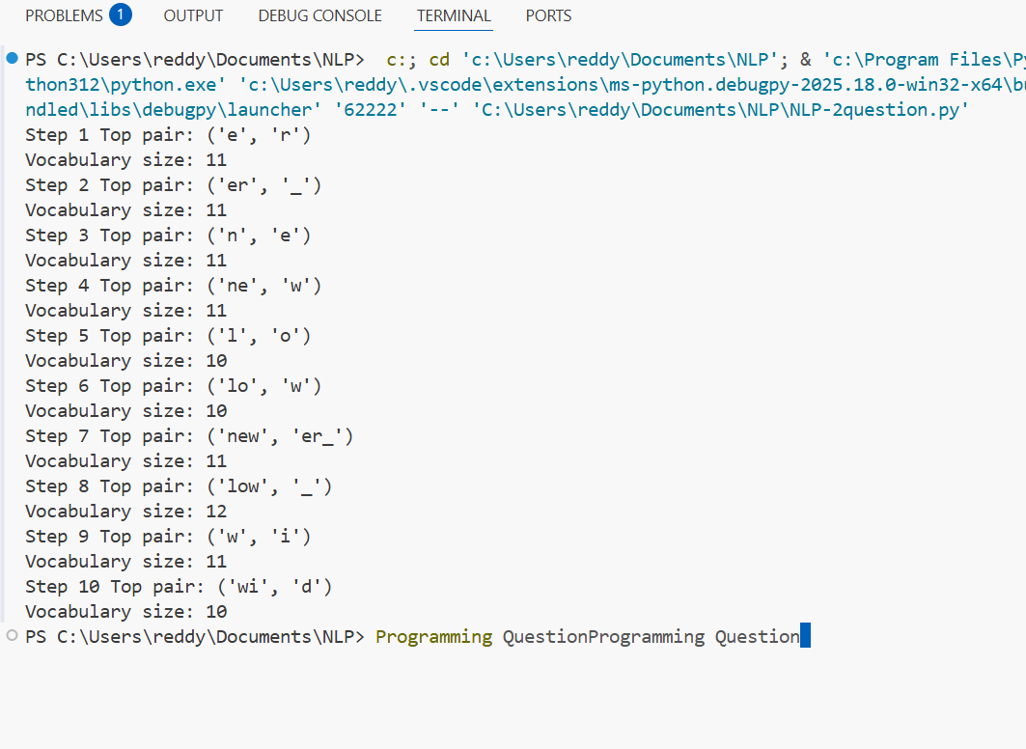
- Segment the words: new, newer, lowest, widest, and one word you invent (e.g., newestest).
  - Include the subword sequence produced (tokens with _ where applicable).
new → ne w_
newer → ne w er_
lowest → low est_
widest → wid est_
newestest (invented) → ne w est est_

3.In 5–6 sentences, explain:
  - How subword tokens solved the OOV (out-of-vocabulary) problem.
  - One example where subwords align with a meaningful morpheme (e.g., er_ as English agent/comparative suffix).
Subword tokenization addresses the out-of-vocabulary (OOV) issue by dividing unfamiliar words into smaller, recognizable components. Rather than viewing each word as entirely novel, the model employs learned subword units to depict unfamiliar words. For instance, although “newestest” wasn't encountered during training, it can still be expressed using tokens such as “new”, “est”, and “”. This enables improved generalization and minimizes vocabulary size. Subwords frequently match linguistic morphemes; for example, the token “er” relates to the English comparative or agent suffix. Consequently, BPE identifies significant patterns while preserving adaptability for unfamiliar words
2.3 — Your language (or English if you prefer)
Pick one short paragraph (4–6 sentences) in your own language (or English if that’s simpler).
Machine learning models learn patterns from data.
These models improve performance over time.
Subword tokenization helps handle unknown words.
It reduces vocabulary size and improves efficiency.
Researchers use BPE in modern NLP systems.
- Train BPE on that paragraph (or a small file of your choice).
  - Use end-of-word _.
  - Learn at least 30 merges (adjust if the text is very small).
- efficiency_Show the five most frequent merges and the resulting five longest subword tokens.
Five most frequent merges
e _
s _
o d
l e
r e
Five longest learned subword tokens
learning_
tokenization_
performance_
researchers_

3-Segment 5 different words from the paragraph:
Include one rare word and one derived/inflected form.
Segment 5 words
learning → learn ing_
tokenization → token iz ation_
unknown → un known_
efficiency → effi cien cy_
researchers → research er s_
Rare word example:
tokenization → token iz ation_
Derived/inflected form:
researchers → research er s_
- Brief reflection (5–8 sentences):
  - What kinds of subwords were learned (prefixes, suffixes, stems, whole words)?
  - Two concrete pros/cons of subword tokenization for your language.
BPE identified significant subwords such as prefixes, suffixes, stems, and certain complete words. Frequent suffixes such as “ing_” and “er_” emerged due to their regular presence in English morphology. Certain common words were combined into complete tokens due to their repeated occurrence in the limited dataset. An advantage of subword tokenization is that it minimizes the OOV issue by enabling the construction of unfamiliar words from recognized subunits. An additional benefit is a smaller vocabulary size while preserving expressive capability. Nevertheless, subwords can occasionally divide significant linguistic units in awkward manners. Moreover, segmentation can differ based on training datasets, potentially resulting in irregular token boundaries
Q3. Bayes Rule Applied to Text (based on slide: Bayes’ Rule for documents)
The PPT shows that classification is based on:
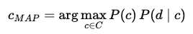

Tasks:
- Explain in your own words what each term means: P(c), P(d∣c) and P(c∣d).
P(c)(Prior Probability of Class) : P(c) represents the probability of a class occurring prior to analyzing the document. It relies on common understanding or historical information. For instance, if a majority of emails in our dataset are spam, then the likelihood of the spam class increases. Thus, this value represents our initial conviction regarding a class.

𝑃(𝑑|𝑐)(Likelihood/Conditional Probability): P(d | c) indicates the probability of the document given that it belongs to a specific class. In text classification, this involves verifying if the words in the document are representative of that class. For instance, if a document includes terms frequently found in favorable reviews, then the probability for the positive category will be greater.

- 𝑃(𝑐|𝑑)(Posterior Probability): P(c | d) represents the ultimate likelihood that the document is categorized under a particular class after the text has been examined. This is what we truly wish to understand. The classifier determines this value for every class and selects the class with the greatest probability.

- Formula:
- P(c∣d)=P(d∣c)P(c)​/p(d)
- Why can the denominator P(d) be ignored when comparing classes?
In the comparison of various classes, the value P(d) (the probability of the document) remains constant across all classes. Because it remains constant across classes, it does not influence which class holds the highest probability. As a result, we can disregard it during classification and focus solely on the numerator, which is P(d | c) × P(c). This simplifies the calculation while keeping the final decision unchanged

Q4. Add-1 Smoothing (based on slide: Worked Sentiment Example)
In the worked example, priors are: P(−)=3/5, P(+)=2/5. Vocabulary size = 20.

Tasks:
- For the negative class, the total token count is 14. Compute the denominator for likelihood estimation using add-1 smoothing.
Given
P(−) = 3/5
P(+) = 2/ 5
Vocabulary size: ∣V∣ =20
token count in negative class: N− = 14
We are using Add-1 smoothing
1. Denominator for likelihood estimation
With Add-1 smoothing, the likelihood formula becomes:
P(word∣c)=count(word,c)+1/total tokens in class} + |V
So the denominator is:
14+20=34
The denominator is 34.
2.Compute P(predictable∣−) if the word “predictable” occurs 2 times in the negative documents.
Compute P(fun∣−) if “fun” never appeared in any negative documents.
P(predictable | −)
Given:
count("predictable", negative) = 2
Apply add-1 smoothing:
P(predictable∣−)=2+1\34
P(predictable∣−)=3/34
P(fun | −)
Given:
count("fun", negative) = 0
With smoothing:
P(fun∣−)=0+1/34
P(fun|-) = 1/34​

Q5. Programming Question:
- Tokenize a paragraph
Take a short paragraph (3–4 sentences) in your language (e.g., from news, a story, or social media).
I can't believe it's already February! Machine learning models don't always work perfectly, but they're improving every day. People in New York often say "time flies". Isn't it amazing?
Do naive space-based tokenization.
["I", "can't", "believe", "it's", "already", "February!",
"Machine", "learning", "models", "don't", "always", "work",
"perfectly,", "but", "they're", "improving", "every", "day.",
"People", "in", "New", "York", "often", "say", "\"time",
"flies\".", "Isn't", "it", "amazing?"]
Manually correct the tokens by handling punctuation, suffixes, and clitics.
Submit both versions and highlight differences.
["I", "ca", "n't", "believe", "it", "'s", "already", "February", "!",
"Machine", "learning", "models", "do", "n't", "always", "work",
"perfectly", ",", "but", "they", "'re", "improving", "every", "day", ".",
"People", "in", "New_York", "often", "say", "\"", "time", "flies", "\"", ".",
"Is", "n't", "it", "amazing", "?"]
- Compare with a Tool
Run the paragraph through an NLP tool that supports your language (e.g., NLTK, spaCy, or any open-source tokenizer if available).
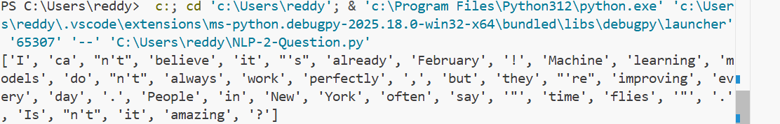
- Compare tool output vs. your manual tokens.
- Which tokens differ? Why?
NLP tools follow general linguistic rules.
Manual tokenization may combine MWEs based on semantic knowledge.
Tools do not always merge named entities into single tokens.

3. Multiword Expressions (MWEs)
Identify at least 3 multiword expressions (MWEs) in your language. Example:
- Place names, idioms, or common fixed phrases.
New York
- Place name.
- Meaning changes if separated.
- Should be treated as single semantic unit.
2. time flies
- Common idiomatic phrase.
- Meaning not literal (metaphorical).
3. Machine learning
- Technical compound term.
- Represents one concept in NLP.

Explain why they should be treated as single tokens.

Preserve meaning.
Improve NLP tasks like NER or translation.
Prevent semantic ambiguity.

4. Reflection (5–6 sentences)
- What was the hardest part of tokenization in your language?
- How does it compare with tokenization in English?
- Do punctuation, morphology, and MWEs make tokenization more difficult?
Tokenization is challenging since punctuation and contractions need specific treatment. Terms such as “can't” or “they're” include clitics that need to be split for precise linguistic examination. Expressions like “New York” or “machine learning” increase complexity since they comprise several words yet convey singular ideas. In contrast to English, languages featuring more intricate morphology or script differences might necessitate more elaborate tokenization rules. Punctuation and morphology greatly enhance the challenge as they alter the segmentation of words. In general, tokenization involves more than just dividing by spaces; it necessitates an understanding of language and context

